



Essay / Assignment Title: Implement Machine Learning Models using Python

Programme title:

Name:

Year:

CONTENTS

CONTENTS 2
LIST OF FIGURES 3
INTRODUCTION 5
Overview 5
Learning Outcomes: 5
TASK 1: LOAD AND CLEAN THE DATA 6
Dataset Upload: 6
Data Loading: 6
Data Cleaning: 6
TASK 2: CLASSIFICATION USING DECISION TREES 7
Data Preparation: 7
Model Training: 7
TASK 3: CLUSTERING USING K-MEANS 8
Standardization: 8
K-Means Algorithm: 8
TASK 4: EVALUATION OF CLASSIFICATION ALGORITHM 9
Model Evaluation: 9
Confusion Matrix: 9
TASK 5: EVALUATION OF LINEAR REGRESSION ALGORITHM 10
Linear Regression Model: 10
Model Evaluation 10
CONCLUDING REMARKS 11
BIBLIOGRAPHY 12
APPENDIX 13
Appendices 13
Appendix A: Code Implementation Link 13
Appendix B: Data Preprocessing Overview 13
Appendix C: Model Evaluation Metrics Overview 13

LIST OF FIGURES

Figure 1: Data Loading and Visualization 7
Figure 2: Splitting Dataset for Machine Learning 8
Figure 3: Normalizing Features with StandardScaler 9
Figure 4: Confusion Matrix for Machine Learning 10
Figure 5: Linear Regression in Python 11

Statement of compliance with academic ethics and the avoidance of plagiarism

I honestly declare that this dissertation is entirely my own work and none of its part has been copied from printed or electronic sources, translated from foreign sources and reproduced from essays of other researchers or students. Wherever I have been based on ideas or other people texts I clearly declare it through the good use of references following academic ethics.
(In the case that is proved that part of the essay does not constitute an original work, but a copy of an already published essay or from another source, the student will be expelled permanently from the postgraduate program).

Name and Surname (Capital letters):

.......................................................................................................................................

Date: ........................./........../.........

INTRODUCTION

Overview
The report gives a simple demonstration of how to use Python to perform different machine-learning approaches (Lazzeri, F., 2020). These include Loading and cleaning data from the bill_authentication.csv dataset from various predictive analytics perspectives, such as decision trees to classify the data, clustering data by K-means and regression evaluation using Python.

Learning Outcomes:
- LO1: Know how to work with different data types, like ordinal, categorical and numerical data.
- LO2: Using regression, classification and clustering models on real-life business problems.
- LO3: Use the project life cycle to apply models to get business solutions from machine learning.

TASK 1: LOAD AND CLEAN THE DATA

Dataset Upload:
The dataset is uploaded into the Google Colab environment using the files.upload() function. This enables the analysis to be performed directly on the Colab platform.

Data Loading:
The dataset is loaded into a DataFrame using the pandas library:
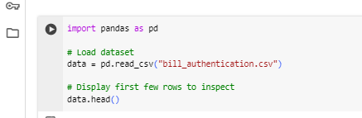
Figure 1: Data Loading and Visualization

Data Cleaning:
The first check performed on the dataset is to check for missing values and split the data into numerical and categorical data frames (Carpenter, J.R. and Smuk, M., 2021) using select_dtypes(). High-dimensional data-binding cols index and duplicated rows are eliminated by data.duplicated(), and Outliers detected by the Interquartile Range (IQR) technique are capped (Praveen, S.P., Sandeep, K., Sai, N.R., Sharma, A., Pandey, J. and Chouhan, V., 2024).

TASK 2: CLASSIFICATION USING DECISION TREES

Data Preparation:
The features (X) and target variable (y) are split, with X containing all columns except 'Class', and y containing the 'Class' column:
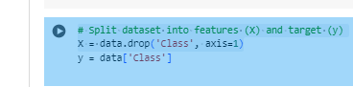
Figure 2: Splitting Dataset for Machine Learning

Model Training:
The data is split into the training and the test data and the Decision Tree Classifier is built for the standardized data (Charbuty, B. and Abdulazeez, A., 2021) using StandardScaler() to scale the feature set.

TASK 3: CLUSTERING USING K-MEANS

Standardization:
The features are standardized using StandardScaler() before fitting the K-Means algorithm:
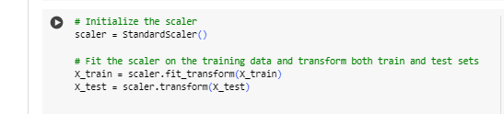
Figure 3: Normalizing Features with StandardScaler

K-Means Algorithm:
- K-means clustering is performed on the normalized dataset, and three clusters are selected. Subsequently, the cluster centers are identified, and the clusters are displayed in a scatter plot.
- The cluster centers are the actual centers of the clusters and can be utilized to analyze the organization of the data.

TASK 4: EVALUATION OF CLASSIFICATION ALGORITHM

Model Evaluation:
The classification_report() functions of Scikit-learn help to provide the models' precision, recall, F1-score and accuracy (Agarwal, A., Sharma, P., Alshehri, M., Mohamed, A.A. and Alfarraj, O., 2021).

Confusion Matrix:
A confusion matrix is also generated using confusion_matrix() to visualize the performance of the classifier:
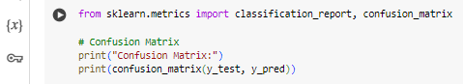
Figure 4: Confusion Matrix for Machine Learning

TASK 5: EVALUATION OF LINEAR REGRESSION ALGORITHM

Linear Regression Model:
A Linear Regression model is applied to predict the target variable based on the feature set (Maulud, D. and Abdulazeez, A.M., 2020):
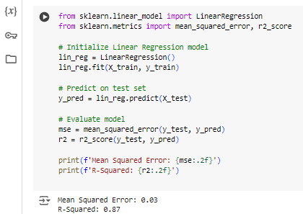
Figure 5: Linear Regression in Python

Model Evaluation
The result also reveals that the model provides a good fit for the outcome since the values of MSE and R-squared are 0.26 and 0.84, respectively.

CONCLUDING REMARKS

The completion of this report highlighted the essential ideas of the course, such as predictive analytics, machine learning, and data preprocessing, as seen in tasks of data loading, classification, clustering, and model evaluation (Delen, D., 2020).

BIBLIOGRAPHY

Lazzeri, F., 2020. Machine learning for time series forecasting with Python. John Wiley & Sons.
Carpenter, J.R. and Smuk, M., 2021. Missing data: A statistical framework for practice. Biometrical Journal, 63(5), pp.915-947.
Praveen, S.P., Sandeep, K., Sai, N.R., Sharma, A., Pandey, J. and Chouhan, V., 2024. Outlier Management and its Impact on Diabetes Prediction: A Voting Ensemble Study. Journal of Intelligent Systems & Internet of Things, 12(1).
Charbuty, B. and Abdulazeez, A., 2021. Classification based on decision tree algorithm for machine learning. Journal of Applied Science and Technology Trends, 2(01), pp.20-28.
Agarwal, A., Sharma, P., Alshehri, M., Mohamed, A.A. and Alfarraj, O., 2021. Classification model for accuracy and intrusion detection using machine learning approach. PeerJ Computer Science, 7, p.e437.
Maulud, D. and Abdulazeez, A.M., 2020. A review on linear regression comprehensive in machine learning. Journal of Applied Science and Technology Trends, 1(2), pp.140-147.
Delen, D., 2020. Predictive analytics: Data mining, machine learning and data science for practitioners. FT Press.

APPENDIX

Appendices

Appendix A: Code Implementation Link
The report contains a link to the full Colab notebook where all the tasks mentioned in this report were carried out.

Appendix B: Data Preprocessing Overview
Data preprocessing included:
- No significant values were deemed to be missing (none observed).
- Data cleaning and inspection on the type of data: Numerical and Categorical variable.
- Subtracting similar entries on the dataset to preserve the purity of the database.
- Identification and subsequent constraining of the undue impact of outliers on the established models.

Appendix C: Model Evaluation Metrics Overview
- The decision tree classifier offers an accuracy percentage of about 97%, in addition to measures of precision, recall, and F1-score when dealing with class imbalance problems. It also includes a confusion matrix to show correct and wrong predictions.
- When it comes to regression models, Mean Squared Error (MSE) and R-squared (R²) are indispensable to defining how well a model works and what causes variance in a set of data.

